Program Information | [Lesson Title]  Walking the Grid |  |  |  |  | TEACHER NAME |  |  | PROGRAM NAME
Program Information | [Unit Title] |  |  |  |  | NRS EFL(s)  3 – 4 |  |  | TIME FRAME  120 – 240 minutes
Instruction | ABE/ASE Standards – Mathematics
Instruction | Numbers (N) |  |  | Algebra (A) |  | Geometry (G) |  |  | Data (D)
Instruction | Numbers and Operation |  |  | Operations and Algebraic Thinking |  | Geometric Shapes and Figures |  | G.4.1, G.4.3, G.3.4 | Measurement and Data | D.3.2
Instruction | The Number System |  |  | Expressions and Equations |  | Congruence |  |  | Statistics and Probability
Instruction | Ratios and Proportional Relationships |  |  | Functions |  | Similarity, Right Triangles. And Trigonometry |  | G.4.8, G.4.9 | Benchmarks identified in RED are priority benchmarks. To view a complete list of priority benchmarks and related Ohio Aspire lesson plans, please see the Curriculum Alignments located on the Teacher Resource Center (TRC).
Instruction | Number and Quantity |  |  |  |  | Geometric Measurement and Dimensions
Instruction |  |  |  |  |  | Modeling with Geometry
Instruction | Mathematical Practices (MP)
Instruction | ☑ | Make sense of problems and persevere in solving them. (MP.1) |  |  |  | ☑ | Use appropriate tools strategically. (MP51)
Instruction | ☑ | Reason abstractly and quantitatively. (MP.2) |  |  |  | □ | Attend to precision. (MP.6)
Instruction | ☑ | Construct viable arguments and critique the reasoning of others. (MP.3) |  |  |  | □ | Look for and make use of structure. (MP.7)
Instruction | ☑ | Model with mathematics. (MP.4) |  |  |  | □ | Look for and express regularity in repeated reasoning. (MP.8)
Instruction | LEARNER OUTCOME(S)  Students will be able to identify coordinate systems and plot points on a graph. In addition, they will use the Pythagorean Theorem to solve contextual problems. |  |  |  |  | ASSESSMENT TOOLS/METHODS  Each of the “You do” steps will serve as assessment. The instructor should be able to gauge understanding by having different students provide their solutions and explanations of how they arrived at that solution. In addition, during the “We do” steps, instructors should be encouraging all students to participate in the discussion. The ability to provide input in these discussions will help the teacher gauge each student’s mastery of the concepts.  Have students turn in the final sheet of the Gridiron City handout if they used it with a partner to find coordinates and plot points. In addition, have them turn in any calculations of distances between cities on the map of Ohio from Part 4. And to check for Pythagorean Theorem understanding, have them work out one or two contextual examples to check from the site below.
Instruction | LEARNER PRIOR KNOWLEDGE  Ability to define and identify spatial relationships: vertical, horizontal, adjacent.  Ability to identify and define points, lines, rays, segments, and planes in mathematical and everyday settings.
Instruction | INSTRUCTIONAL ACTIVITIES  Note: Keep in mind that your class may not need to go through each of the parts below. Please pick and choose which elements to incorporate into your actual lesson based on what you know of your students. In addition, extra sample problems may need to be incorporated based upon your particular class. See the technology integration portion for a website that gives many example problems.  Part 1: When looking at maps, it is often beneficial to round distances. Depending on the length of travel, distances will likely be rounded to the nearest 10 or 100. There are two keys when rounding numbers to a specific place value. The first is knowing the different place values, and the second is knowing whether to round up or down. Let’s address the issue of place value first. Let’s consider a distance of 1,234.56 miles. This number incorporates multiple place values and gives a different numerical value for each place. This way you can just say, “Which place value is the 3 in?” to indicate the place value. With this number, you want to notate each of the place values. From left to right they are: thousands, hundreds, tens, ones, tenths, and hundredths.  (Note: This would be a time that you could introduce expanded notation if you wanted. Expanded notation would write the above number as: .)  (I do) Let’s say that 1,234.56 is the distance we will be travelling to get to my vacation destination. We eventually want to be able to round to any place value, but let’s start with the most common for distances: hundreds, tens, and ones.  When rounding, we can think about making a list of the steps we should follow:  Identify the place value you are rounding to.  Look at the number immediately to the right of this place value.  -If this number is a five, six, seven, eight, or nine then we “round up.” This means we will add one to the number in the place value we are rounding to and change all numbers to the right of that place value to a zero.  -If this number is a zero, one, two, three, or four then we “round down.” This means we will leave the number in the place value we are rounding to alone, but still change all numbers to the right of that place value to a zero.  If we actually do some problems using these steps, rounding may become clearer. For instance, if we round to the hundreds we will find the hundreds place first: . Then, we will look at the number immediately to the right: . Since this value is a three, we follow 3b and “round down.” So we leave the 4 alone, and change everything to the right of the 4 to a zero: .  If we round to the nearest ten we will first find that place value: . Next we look at the number immediately to the right: . We have a four, so again we “round down”: .  If we round to the nearest mile we first identify that place value: . Next, we look to the value to the right: . This time the five tells us to “round up.” This means we add 1 to the 4 in the ones place and change all numbers to the right to a zero: .  (We do) Now, the class will work with you and guide you through the rounding process. Use this number (or make up one of your own): miles.  If we round to the nearest hundred miles we will first find that place value: miles. Next we look at the number immediately to the right: . We have a one, so we “round down”: .  If we round to the nearest ten we will first find that place value: miles. Next we look at the number immediately to the right: . We have an eight, so this time we “round up”: .  If we round to the nearest mile we first identify that place value: miles. Next, we look to the value to the right: . Again, the nine tells us to “round up”: .  (You do) Now have the students work on their own (or in pairs) using a new number. (Suggestion: miles or have them find the distance between two locations.)  Part 2:  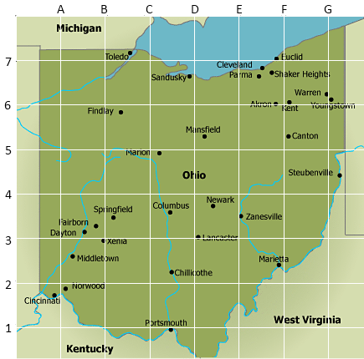  Maps like the one above are quite common. Many now come with grid overlays as well as an index to easily find cities. For instance, maybe you are from out of state and want to find Cincinnati. You aren’t sure exactly where to look on the map, but the index will list the cities alphabetically along with a coordinate to help you find each space. We will come back to this map once we know a bit more about graphs and coordinates.  Part 3: Let’s begin with what may be a simpler map and scenario. Make sure everyone has the Gridiron City handout. The SmartPal kits may prove useful as well so that students can write “on” the handout and make corrections as needed. Go through the scenario on the first and second page with the class, including the questions. On the second page, the movie theater is a half mile from the grocery store (2 quarter-mile gridlines) and the stadium is 1 and of a mile from the department store (7 quarter-mile gridlines). In order to find an answer to the final question, we need to put the circus on our sketch. This happens on the third page. Now that we have a coordinate grid, go over some vocabulary. Necessary terms are: coordinate grid (coordinate plane), origin, axes (x-axis and y-axis), quadrants, and coordinates. Once the terms are out there, go over how to find coordinates.  (I do) (This will be a fairly quick explicit instruction model.) Starting with point A, we will eventually find the coordinates of each of the six points on the graph.  (Understand the problem) Using what we know about a coordinate plane and axes, we want to come up with the coordinates of the movie theater (A).  (Pick a strategy) We will use our knowledge that the distance between grid lines is (of a mile). Otherwise, there are not really multiple strategies to use here.  (Implement the strategy) If we go to the point on the grid, we want to find the x-coordinate and y-coordinate. If we travel straight down along the vertical grid line that A sits on, we will arrive at the x-axis. We then want to count back to the origin and we see that we were two steps away from the origin. So our x-coordinate is . We want to do the same thing for our y-coordinate. This time, from A, we will travel left along that grid line until we reach the y-axis. We then see we are 4 steps from the origin. So our y coordinate is . Thus, our ordered pair for point A is  (Review) We can double check this by finding the intersection of 1/2 on the x-axis and 1 on the y-axis. We can do this by placing a finger on each value, and traveling into the first quadrant until they intersect. We know to go to the first quadrant since both values are positive. (In the second quadrant the x-value is negative and the y-value is positive, in the third quadrant the x-value is negative and the y-value is negative, and in the fourth quadrant the x-value is positive and the y-value is negative.)  (We do) As a class, have the students help you find the coordinates of the grocery store (B): . You may also do point C, or save that for the students to do alone.  (You do) Have the students do any remaining points on the graph. For additional practice, pair them up and have them use the graphs on the 4th page of the handout to plot points and have their partner find the coordinates, or state coordinates and have their partner plot the point. [Point D: , Point E: , Circus: .]  Part 4: Now we are going to work on distance and lines. One of the previous questions was about the distance from the circus to the amusement park (the blue dot at the origin to point E).  (I do)  (Understand the problem) We can have the students come up with different routes to get from one place to the other. If we are driving, we will have to follow the gridlines as those are the roads. If we start at the origin (the circus) we can travel east until we are directly north of the park. We can then go south until we reach the park. This would have us traveling 13/4 or 3 and 1/4 miles (7/4 east, 6/4 south). Is there a shorter route? What if we were walking and were able to cut across the gridlines?  (Pick a strategy) There is a distance formula when we know coordinates that will tell us the distance between two points. That formula tells us that the distance = .  (Implement the strategy) In our case, let’s call our first point the circus position, which is at the origin, or (0,0). Our second point , then, is the park located at . Using the formula above, we get:  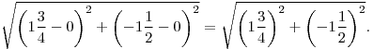  Simplifying this will give us:  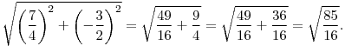  Using a calculator (or, if you have covered simplifying fractions and square roots, doing it by hand) we will find that the distance here is about 2.3 miles, which is significantly less than if we had followed the gridlines.  (Review) If we draw the possible routes in – first the one that goes east and then south, and then the one that cuts across diagonally – we will see that a triangle is formed. Since a property of triangles is that the sum of two sides must be greater than the third side, we knew that the distance we found in step 3 would be less than the first way of travelling.  (We do) If the circus troupe wants to see a movie that doesn’t begin until 8pm and they want to kill time until then at the department store, how far will they have to travel? Call the department store point 1 , and the movie theater point 2 . Then we have:  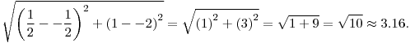  (You do) Have the students check other points. They can even use the formula to recheck the easier distances (A to B, C to D).  Part 5: Now let’s go back to our original map (give students the Mapping it Out handout so they can use it in their SmartPals to do the activity):  We know now that we can describe points based on ordered pairs. Let’s re-label along the top so that we have numbers that we can put into our distance formula. A=1, B=2, C=3, D=4, E=5, F=6, and G=7.  (I do) Let’s say we want to find the distance from Lancaster to Xenia.  (Understand the problem) We see that Lancaster is basically at the intersection given by (D3) or (4,3). Xenia is also basically at an intersection (B3) or (2,3). Since we have ordered pairs we can find the distance.  (Pick a strategy) We will use the ordered pairs above as well as the distance formula. (As these are simply a horizontal distance, we could just count, but let’s reinforce the formula.) Let Xenia be point 2 and Lancaster be point 1.  (Implement the strategy)  We are not done however, as the answer just tells us the distance if we consider the distance between grid lines to be “1”. The distance between gridlines is 40 miles, though. So if we travel a distance of 40 miles twice (since we cross 2 grid lines), we get that the distance from Lancaster to Xenia is about 80 miles.  (Review) We can check this two ways. First, since we had chosen points that we did not have to cut diagonally across grid lines to get the shortest distance, we could have just counted how many grid lines we crossed. Secondly, we could plug this into an online map and find the distance. (Google maps gives me a distance of 79.4 miles from Lancaster to Xenia.)  (We do) As a class, find the distance from Columbus to Norwood. Columbus is pretty much in the center of some grid lines. We will need to estimate its coordinates. Since is seems midway between the lines in both the x- and y-directions, let’s call its coordinates (3.5,3.5). Norwood is quite close to an intersection, so let’s call its coordinates (1,2). Then our distance would be:  2.92 would be the distance if our grid lines were 1 mile apart, instead they are 40 miles apart. So our distance is .  (You do) Have the students answer the remaining questions or pick cities to find the distance between.  Zanesville and Kent:  Multiplying this by 40, we get that the distance is about 107.7 miles.Youngstown and Toledo:  Multiplying this by 40, we get that the distance is about 184.39 miles.  Springfield and Portsmouth:  Multiplying this by 40, we get that the distance is about 116.8 miles.  Part 6: Finally, if time permits, let’s look back to our Gridiron City layout. In part 3, we found the distance from the circus to the amusement park by going east then south. If we draw in that route, as well as the shortcut that we found using the distance formula, we should have a right triangle on our hands. What we just derived was the Pythagorean Theorem. The side we found using the distance formula is across from the right angle, making it the hypotenuse of the triangle. The other two sides, then, are legs. Since distance and length are synonymous here, then we found that squaring the length of one leg and adding it to the square of the other leg gives us the square of the hypotenuse. In other words: leg² + leg² = hypotenuse². Or, more commonly: a² + b² = c², though don’t let the letters throw anyone off in case a leg is labeled “c” and the hypotenuse “a” for instance. It is always leg² + leg² = hypotenuse². Let’s pull some examples off the map.  (I do) If Athens is located 53 miles directly south of Zanesville, and Zanesville is located 56 miles directly east of Columbus, how far is Athens from Columbus?  (Understand the problem) The question is asking us to find the distance. We want to use the distance formula, but we don’t have coordinates. In this situation, we want to draw a picture to see what we have going on. Once we do that, we should have a right triangle. One leg will be the distance from Athens to Zanesville (53 miles) and the other leg will be the distance from Zanesville to Columbus (56 miles). Our hypotenuse then is the missing distance.  (Pick a strategy) Since we have made a right triangle, we want to use Pythagorean Theorem.  (Implement the strategy) leg² + leg² = hypotenuse² will give us 53² + 56² = hypotenuse². We then have 2809 + 3136 = hypotenuse² = 5809. Thus, the hypotenuse, or the distance from Athens to Columbus is roughly 76 miles.  (Review) We can check our work with a calculator, or an online map. Google maps tells me that Athens to Columbus is 75.7 miles.  (We do) Have the class walk you through a similar problem. This time, let’s use a non-map example as the Pythagorean Theorem is useful in multiple contexts, especially involving lengths and distances. Softball infields, while known as diamonds, are actually squares. If the distance between successive bases is 60 feet, how far must the catcher throw the ball if they are trying to throw somebody out at second base? (In other words, if we make a square tipped on its side to resemble a diamond, what is the distance from the bottom point to the top point?) Here we have the Pythagorean Theorem once more. Drawing in that vertical line gives us two right triangles. The hypotenuse is the line we drew in, and all the legs are 60 feet. Thus, leg² + leg² = hypotenuse² will give us 60² + 60² = hypotenuse². Since 60² + 60² = 7200, our distance is about 85 feet.  (You do) (You can use Google maps to find the distance between cities that appear to form right angles, or you can make up problems such as the previous one for more practice. Some contextual examples can be found in the technology integration section.) When building structures, right angles are very important. While putting up the wall frame for a new building, Brad wants to make sure the wall is at a 90 degree angle from the floor. After putting up the wall they put a support beam up to hold it in place. Brad realizes they didn’t grab anything to measure an angle with, so he must figure out a way to check they have a right angle using only his tape measure.  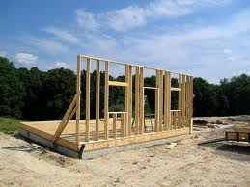  If he measures the angled support to be 4.5 feet, the vertical distance from the floor up the wall to the support as 4 feet, and the horizontal distance from the wall along the floor to the support as 3 feet, is the wall creating a right angle with the floor? Since leg² + leg² = hypotenuse², we want to check if 3² + 4² is the same as (4.5)². Since 3² + 4² = 9 + 16 = 25 and (4.5)² = 20.25, then no, the wall is not square to the floor. |  |  |  |  | RESOURCES  SmartPal kit – inserting a blank sheet of paper into the sleeves will give students a reusable sheet of paper that they can quickly try answers out on and erase without using up a pencil eraser. It’s quicker as well. For this lesson, we will want the grid handout provided inserted.  Calculators (Optional)  Gridiron City – Handout  Mapping it Out – Handout  Http://www.regentsprep.org/regents/math/algebra/at1/pracpyth.htm  Http://www.mathsisfun.com/pythagoras.html
 | DIFFERENTIATION
Reflection | TEACHER REFLECTION/LESSON EVALUATION
Reflection | Additional Information  NEXT STEPS  As we have given ourselves the coordinate grid now, we can easily plot shapes on here. If we make shapes that follow the gridlines, finding perimeter and area of basic/irregular shapes would be a good follow-up. In addition, now that the coordinate grid has been introduced, graphing equations or connecting algebraic and graphical representations of lines/curves would be a good follow-up.  PURPOSEFUL/TRANSPARENT  Since students want to be able to read a map and find distances, instructors will go over what goes into reading a map and plotting coordinates. And, while it will be a rough estimate depending on the way the map is laid out, instructors will go over how to find distance using just coordinates and not a ruler and map scale. Finally, instructors will go over the basics of what lines and curves look like on a graph and why.  CONTEXTUAL  Maps often have a grid overlaid on them now. While they do not have a set of axes as this lesson did, you can still consider one corner the origin as many maps will label boxes by a notation similar to “a4”, where letters denote how far across to go, and numbers denote how far up or down to go. In addition, finding distances between points is a good introduction to the pythagorean theorem which is used in carpentry and other architectural/construction jobs.  BUILDING EXPERTISE  Much of geometry, and algebra, utilizes the coordinate grid. Being able to plot points and interpret what is already on a graph will give students a head start into more advanced topics such as graphing lines and curves.
NOTE: The content in the Additional Information box exceeds what is required for the OBR Approved Lesson Plan Template. This information was provided during the initial development of the lesson, prior to the creation of the OBR Approved Lesson Plan Template. Feel free to remove from or add to the Additional Information box to suit your lesson planning needs.
Mapping it Out
You find the following map of Ohio:

While there is no scale on the map, you are told that the distance between gridlines is 40 miles.
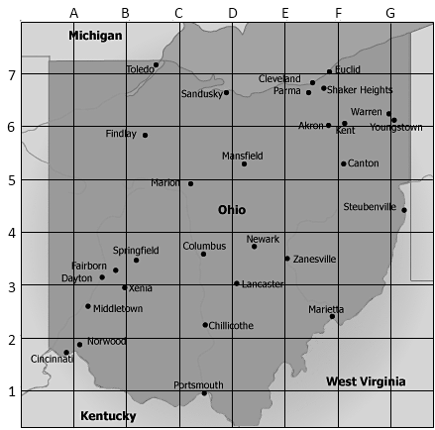
Can you find the distance between Lancaster and Xenia?

Columbus and Norwood?

Zanesville and Kent?

Youngstown and Toledo?

Springfield and Portsmouth?

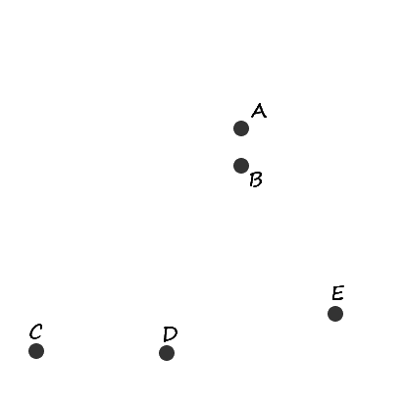
Gridiron City
Nancy is the ringleader of a traveling circus. Due to her job, she often finds herself in new cities on a regular basis. When she tells her crew that they’ll be heading to Gridiron City next, one of the clowns excitedly tells her that’s where he is originally from. She asks if he would give them a few attractions to see, which he agrees to.
He gives them a quick sketch of five places they may be interested in going during their stay in the city. He said he based his sketch on the assumption that the circus will be roughly in the middle of the drawing. His points represent the following places:
- A: Movie Theater
- B: Grocery Store
- C: Sports Stadium
- D: Department Store
- E: Amusement Park
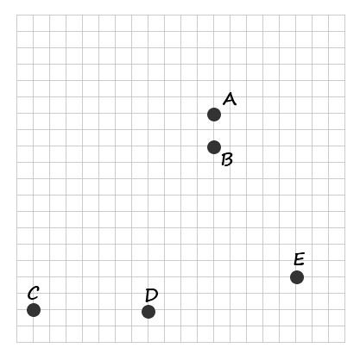
Nancy thanks the clown for his help, but as the crew looks at the sketch they have a bunch of questions. How far away are things? Is the distance between the stadium and the department store really that much further than the distance between the grocery store and movie theater?

After thinking about the questions for a bit, the clown believes that his sketch does have distances between the places preserved. He edits the sketch to include the grid overlay seen below.
Before they can ask him about distances or travel routes, he tells them that each gridline represents a regularly travelled road. When they designed the city, they wanted travel to be easy. In addition, the clown tells them that the distance between each gridline is a quarter of a mile.
How far does this place the Movie Theater from the Grocery Store?
How about the Stadium from the Department Store?
What would the distance be from the circus to the Amusement Park?
How would we go about that?

In order to find the distance from the circus to the Amusement Park, one of the trapeze artists suggests placing a blue dot in the center since the clown said he based his sketch on the circus being near the middle. In addition, the trapeze artist adds in the two darkened lines shown below, saying that it reminds him of the coordinate grid they learned in school.
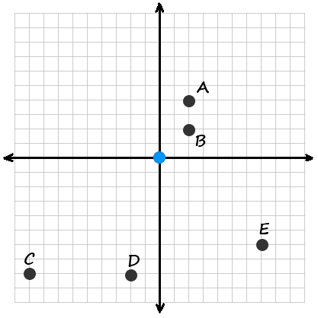
Now, they can give each other directions and find distances using the grid.



